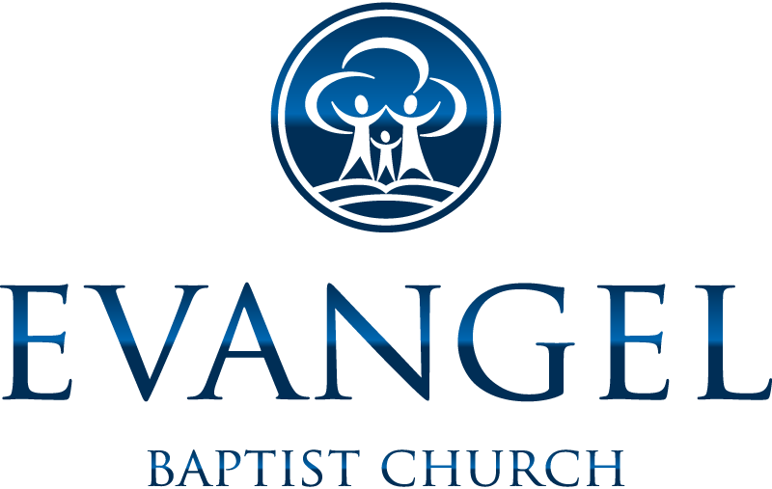

PERMISSION, RELEASE, AND WAIVER FORM
Lake Ann Summer Camp
Activities during 2017

Student Name:
Student Address:

BY Initialing THE ITEM BELOW I’M GIVING MY PERMISSION FOR THE ABOVE NAMED STUDENT TO JOIN THE YOUNG PEOPLE OF EVANGEL BAPTIST CHURCH AT THE ACTIVITY I INDICATE:

________Summer Camp: The young people will be transported by a bus, van or leader’s vehicle to and from camp. While at camp they will be participating in camp activities and be under the authority and protection of the camp staff.

I state that my child is in proper physical condition to participate in the above event’s activities. In consideration that my child has voluntarily agreed to participate in this event, I hereby, for myself, my heirs, executors, and administrators, successors, and assignees, release, forever discharge and hold Evangel Baptist Church the sponsor for this event, its agents, representatives, successors, and assignees, harmless from any and all claims for damages or injuries suffered by my child by his or her participation in the event.
Signature of Parent: ____________________________________________________________________
Date:_________________________ Emergency Phone #: _____________________________________

